Part 1. Practice ‘Basic Plotting Skills’ Examples: Graphs – Gavin Binder

Part 1a.

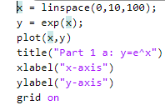

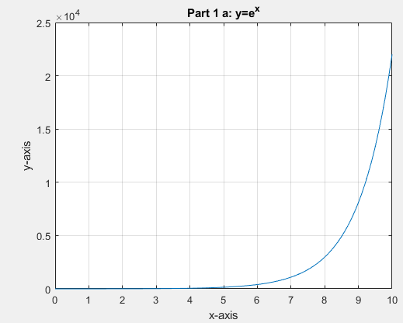

Part 1b.

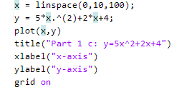

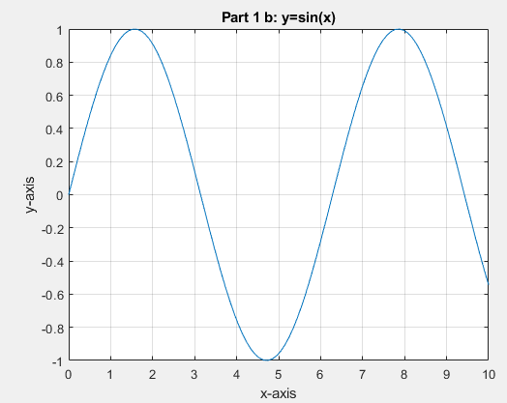

Part 1c.



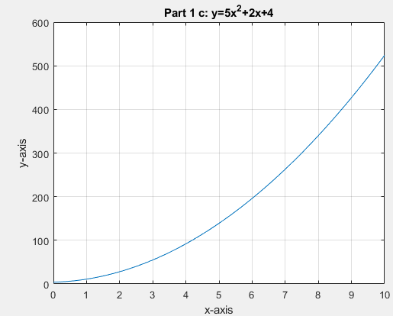

Part 1d.

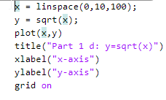

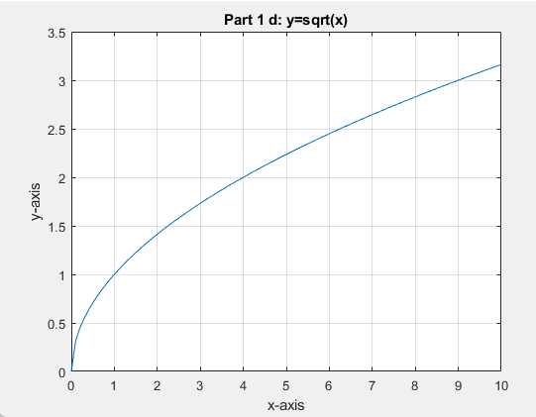

Part 2. ‘More plots with special format’: Graphs – Gavin Binder

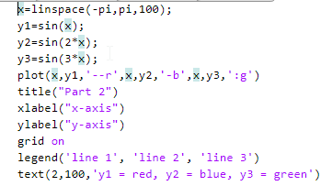

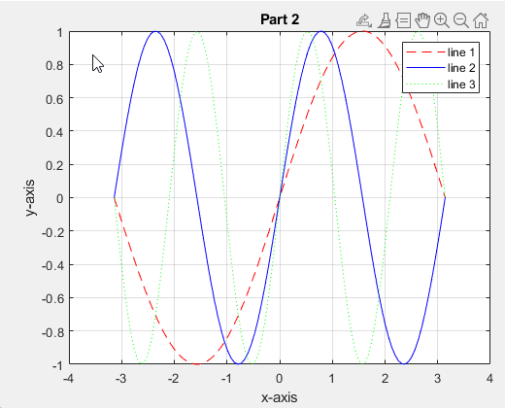

Part 3. Intro to STEM application’ Problem – Projectile motion – Gavin Binder

Part 3a.

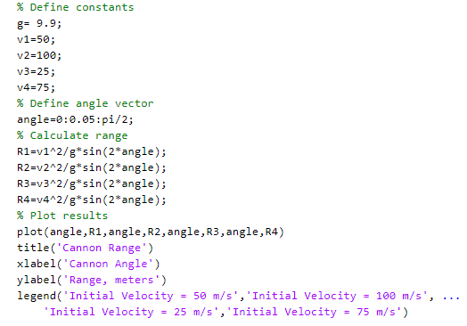

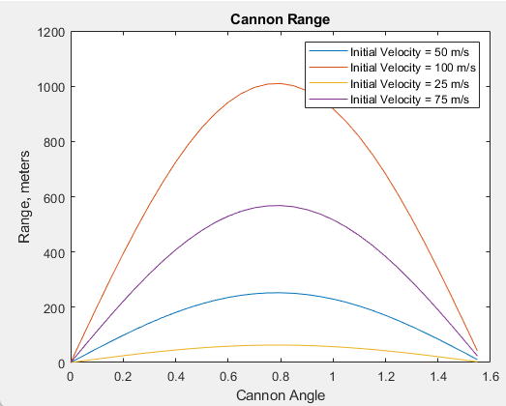

Part 3b.

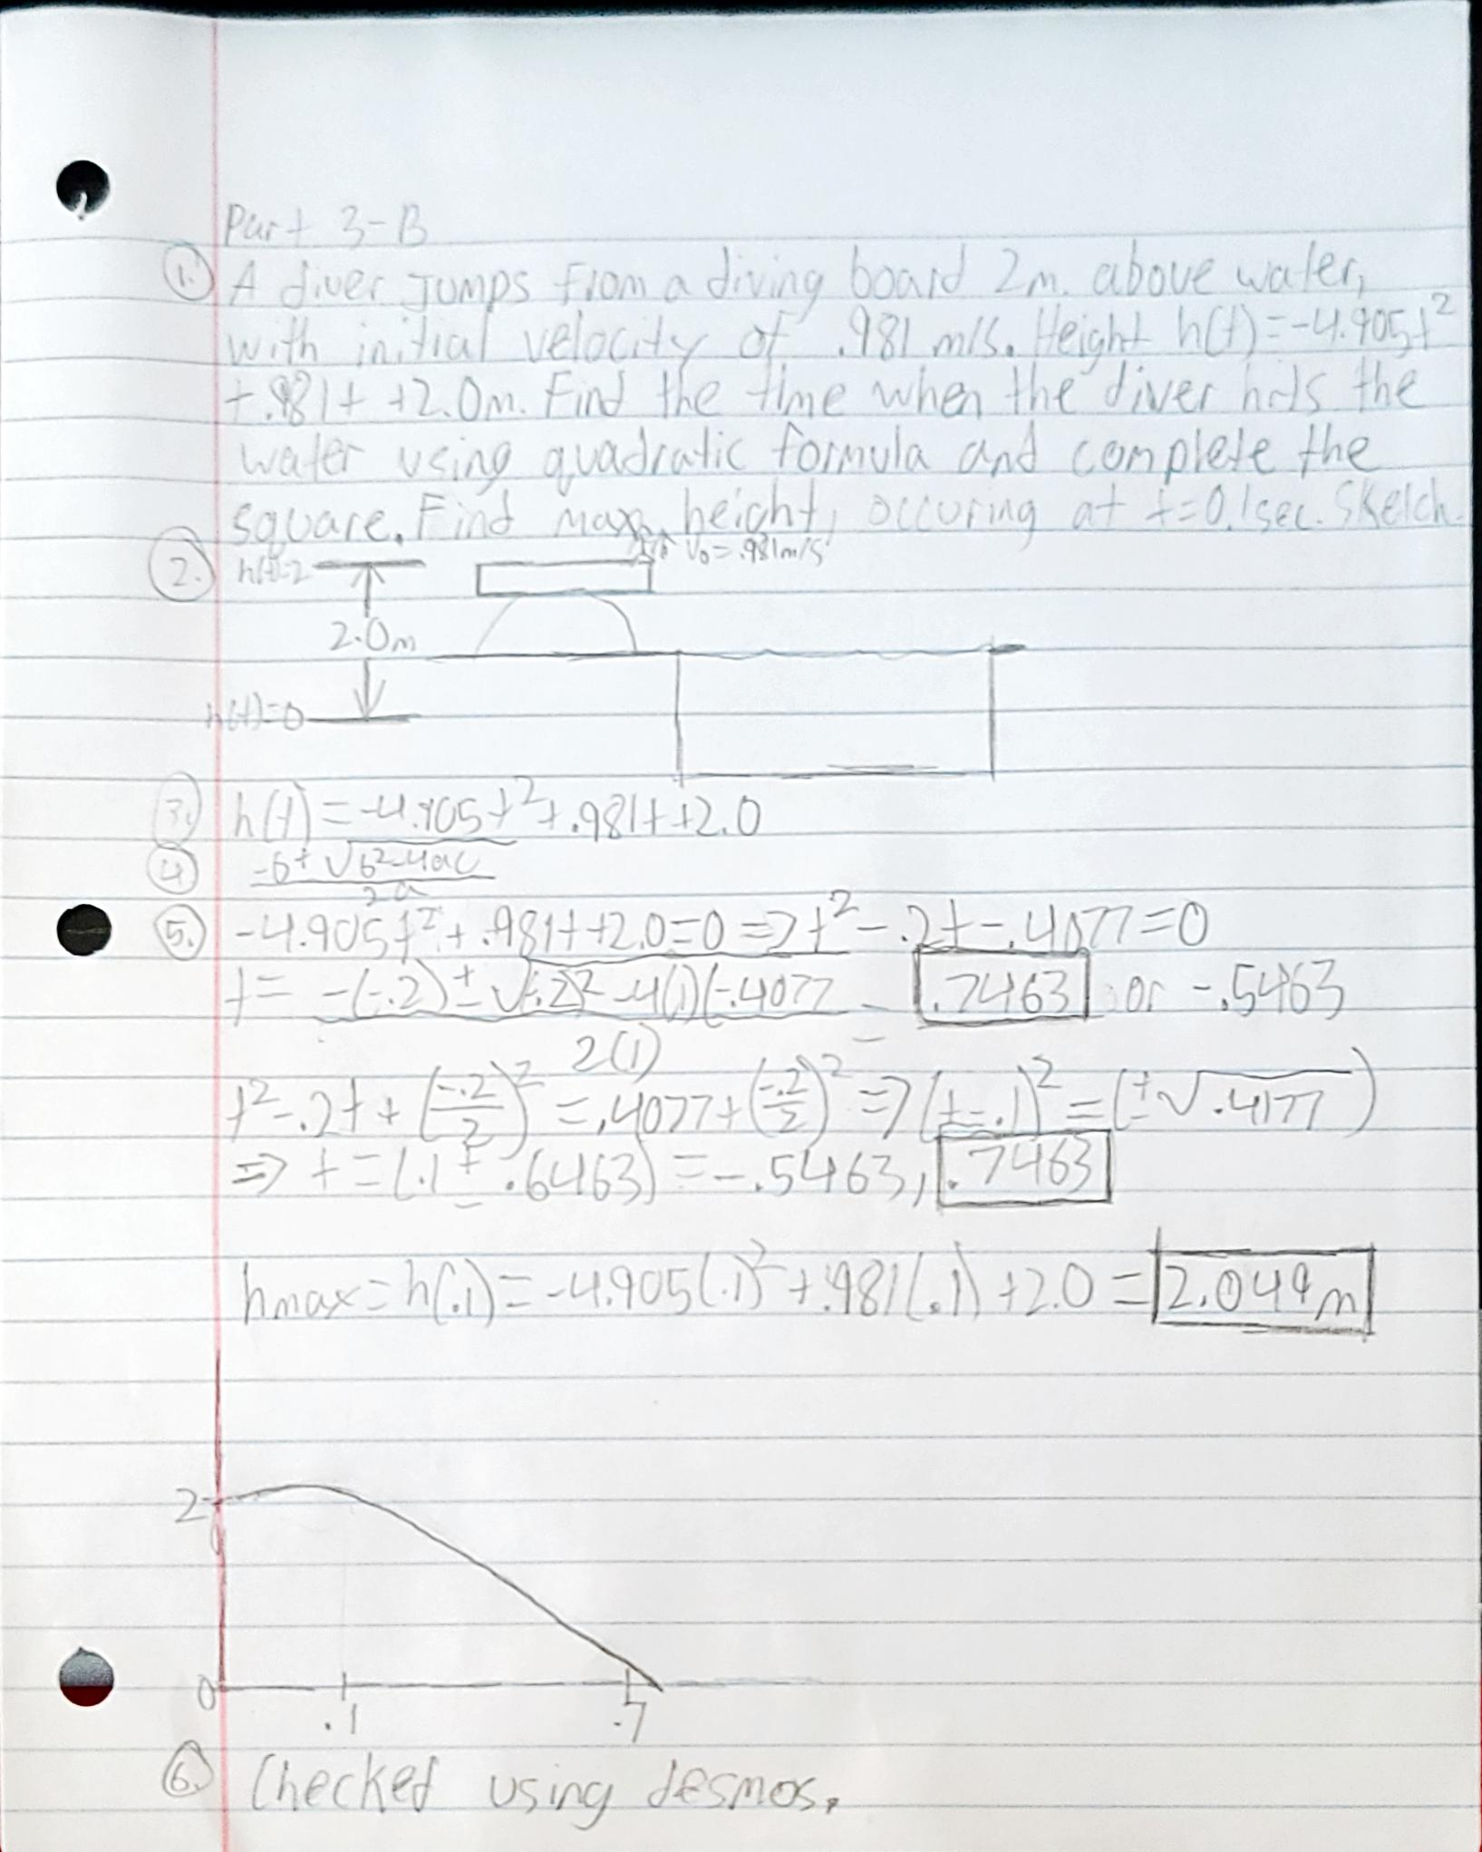

Part 3c.

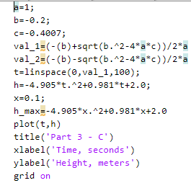

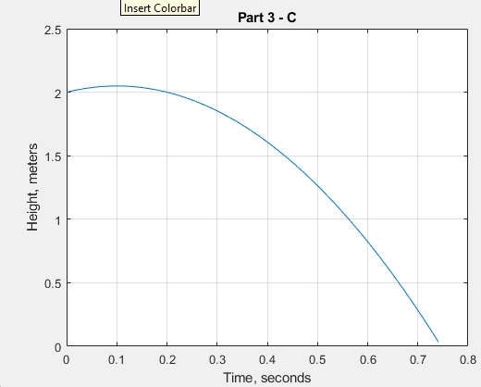

Part 4. Intro to STEM application’ Problem – electrical circuits – Gavin Binder

Part 4a.

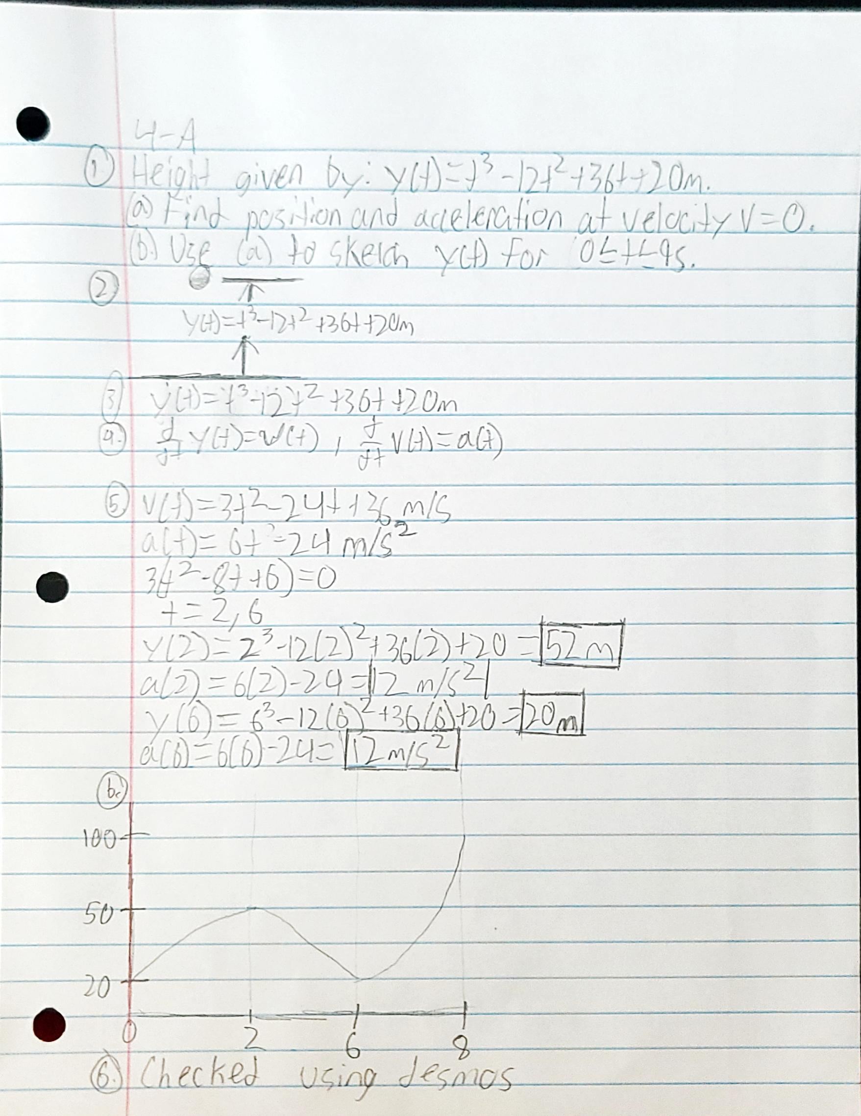

Part 4b.

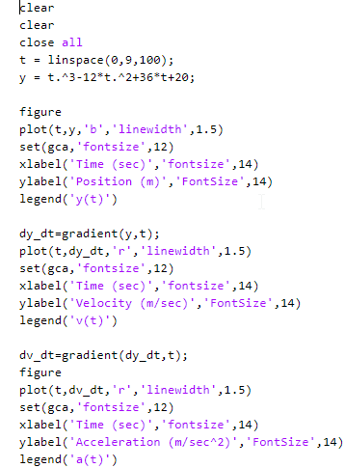

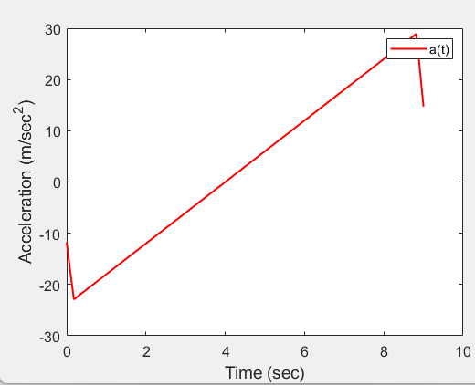

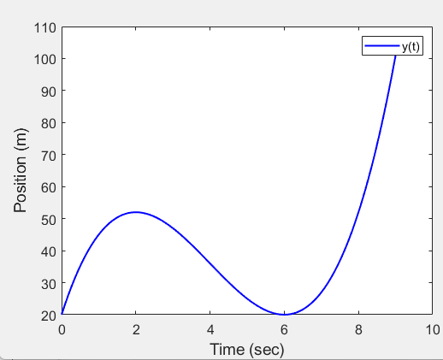

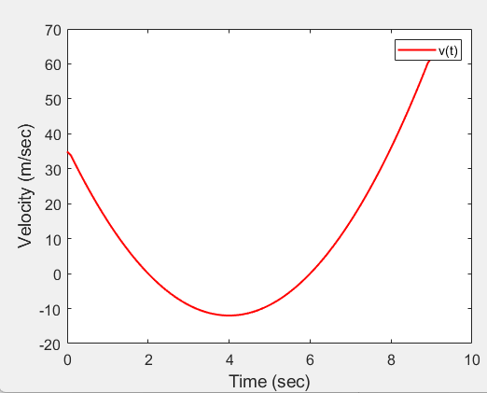

Part 5. Intro to STEM application’ Problem – electrical circuits – Gavin Binder

Part 5a.

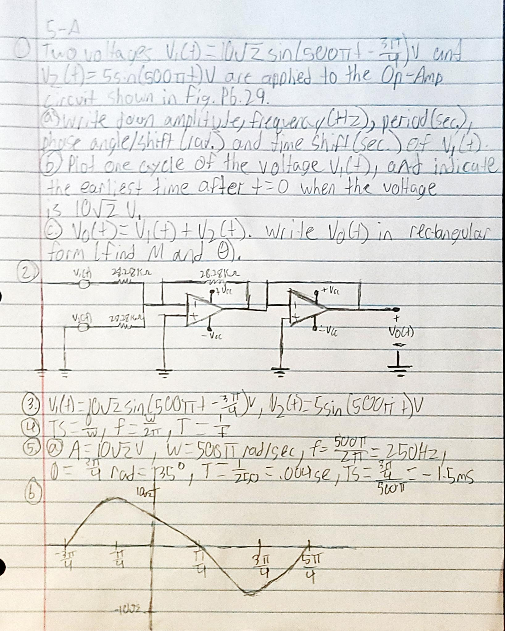

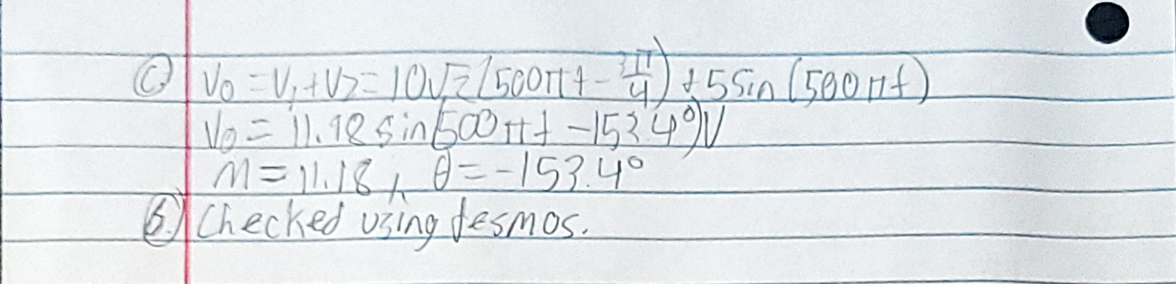

Part 5b.

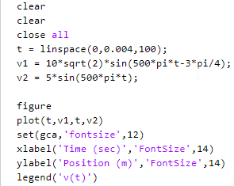

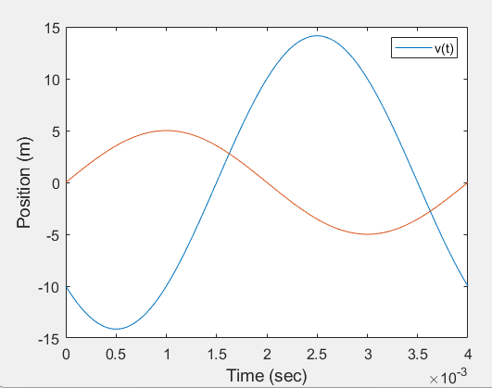

Part 6. Reflection on new P3F group ‘collaboration’ activities

Part 6a

The group consists of myself, Ryan Thompson, and Francisco Ribas. Communication happened mainly through Discord messages, and everything went very smoothly in terms of collaboration. For the presentation, I did the formatting, introduction, and conclusion. Ryan did the calculations and Frankie did the problem statement and MATLAB code. For Mini Project 4, we mostly just helped with the MATLAB portions, helping each other if when we need it.

Part 6b

* Graph manipulation, as MATLAB allows for many different options in terms of formatting and changing graphs to suite your needs.
* Image processing and computer visions, as you can use MATLAB to analyze images and build algorithms.